**Tel.**01387 254 424 @Allied_Scotland

# [www.alliedsurveyorsscotland.com](http://www.alliedsurveyorsscotland.com/)



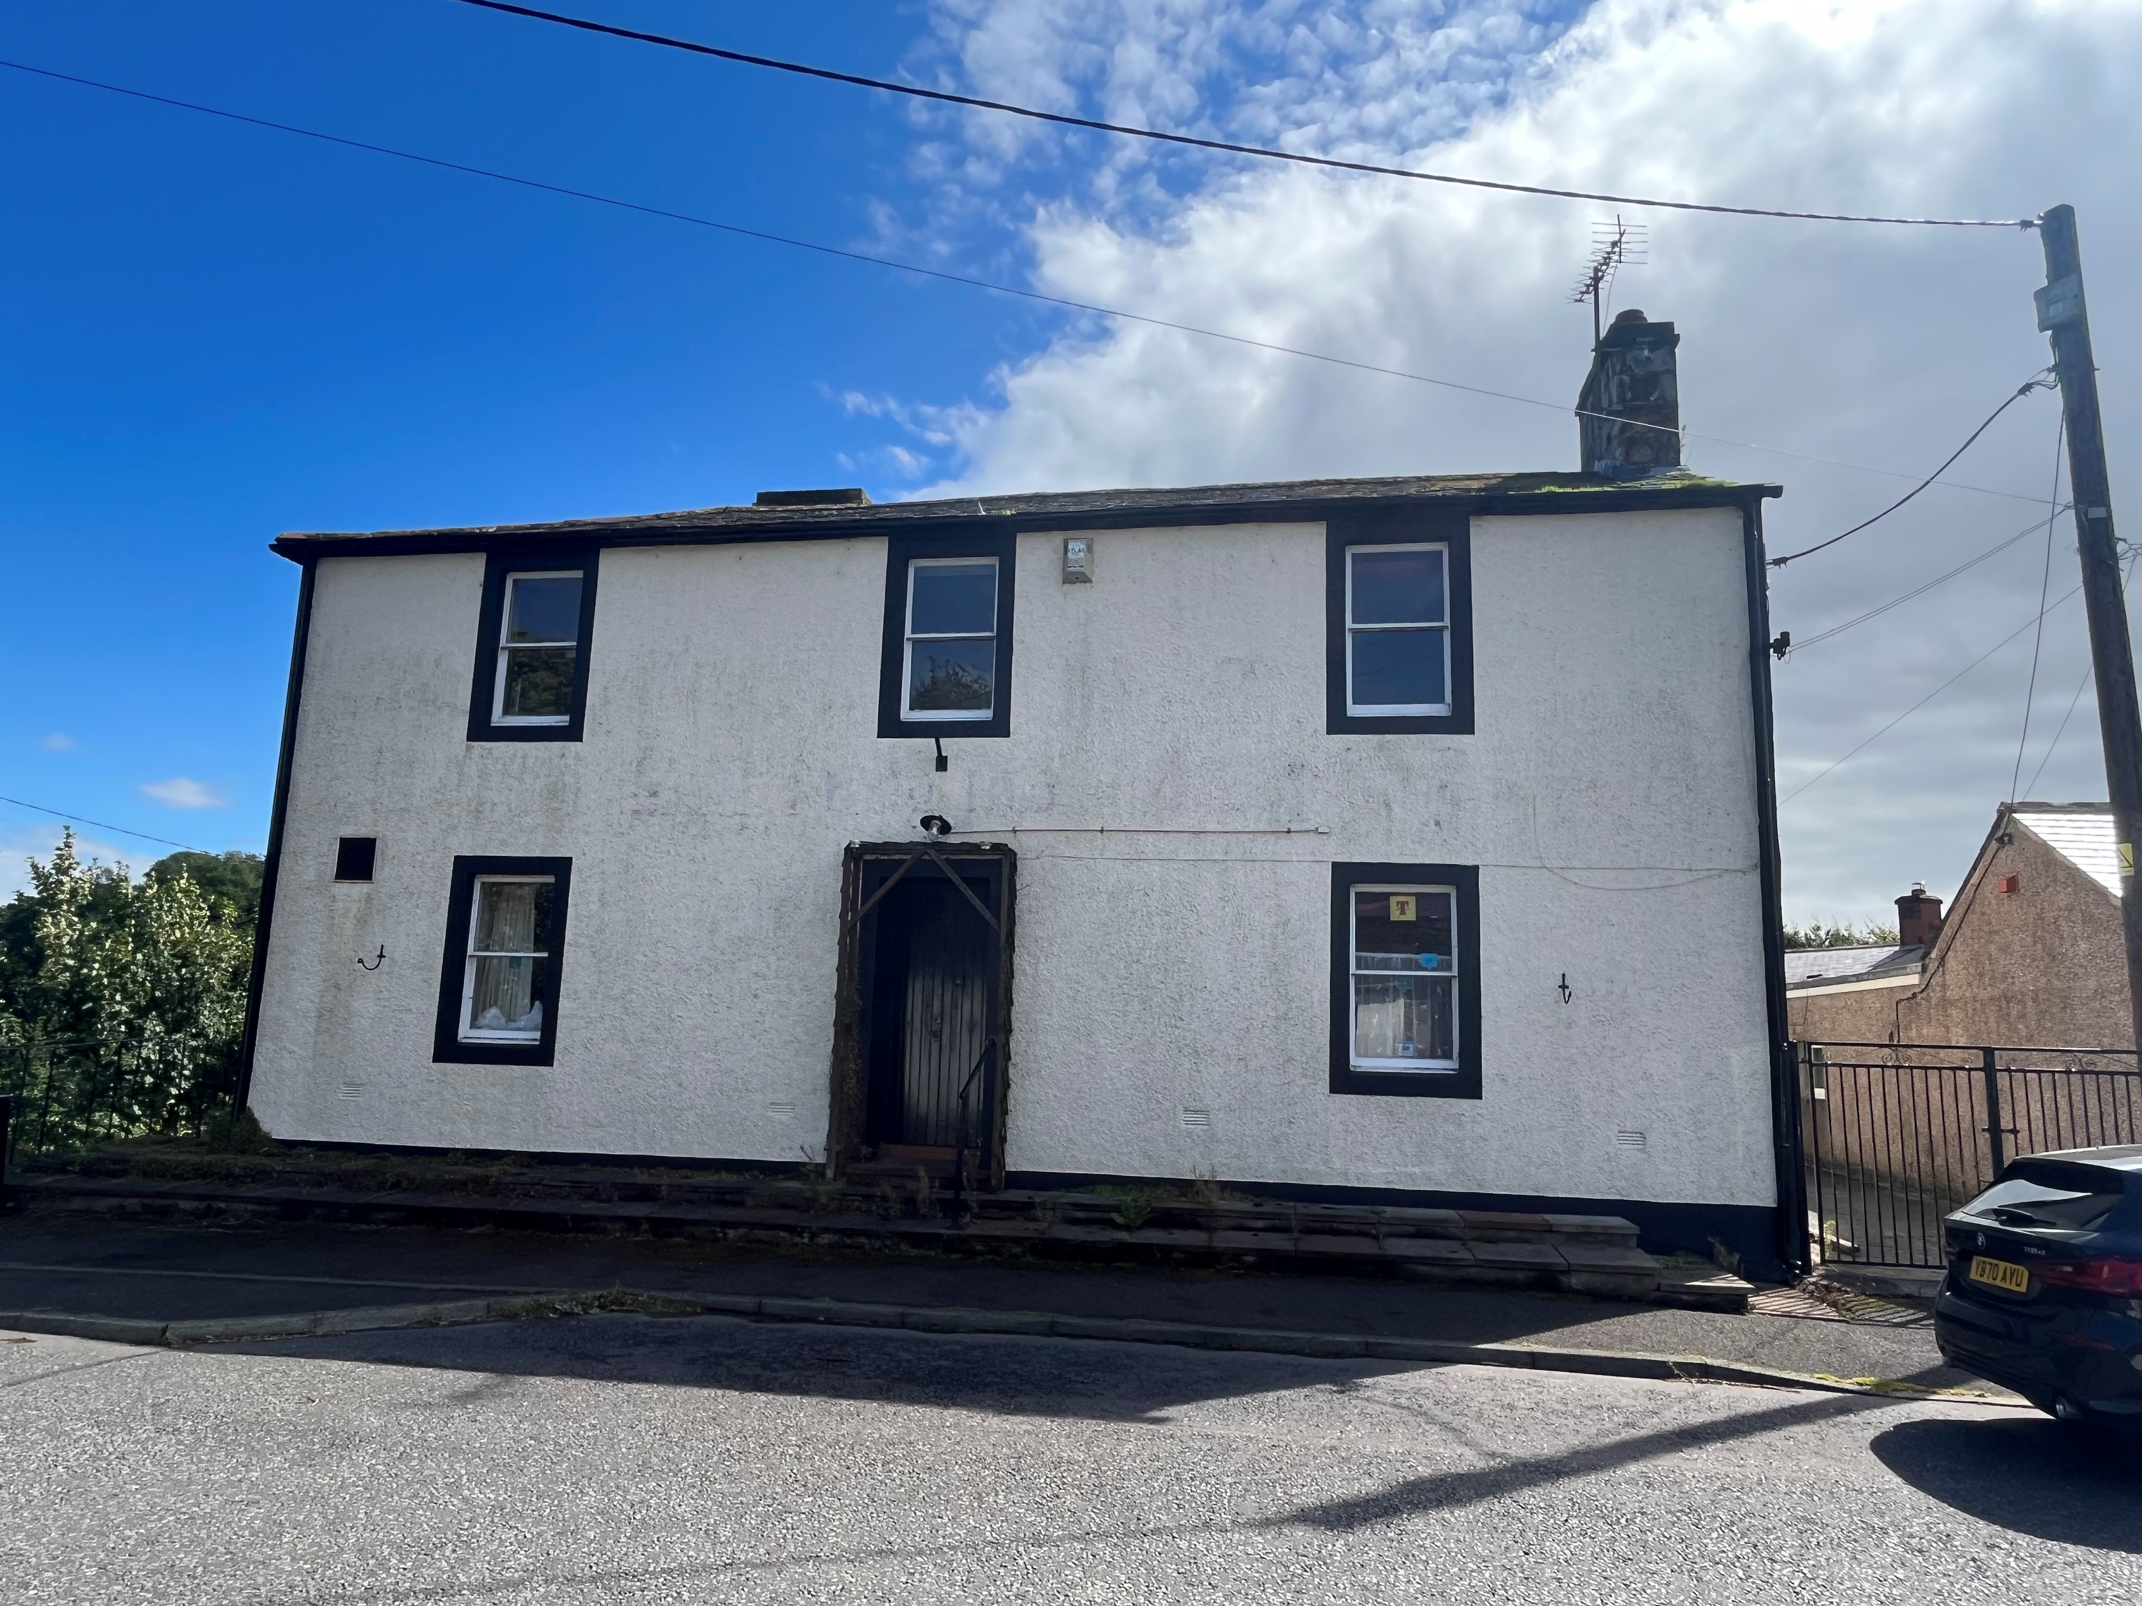

FOR SALE – PUB AND ABOVE FLAT

**THE BRIG INN, BRIDGE STREET, BRYDEKIRK, DG12 5LR**

* PUBLIC HOUSE WITH 2 BEDROOM FLAT ABOVE
* SCENIC LOCATION – RIVER VIEWS TO THE BEER
* TIMBER DECKED BEER GARDEN
* CELLAR WITH EXTERNAL ACCESS

Commercial Valuation | Agency | Investment Advice

Building Consultancy | Lease Renewals and Rent Review | Energy Reports

# LOCATION



**Tel.**01387 254 424

@Allied_Scotland

[**www.alliedsurveyorsscotland.com**](http://www.alliedsurveyorsscotland.com/)

The shop is located on Bridge Street, the main thoroughfare through the village Brydekirk.

# DESCRIPTION

The subjects comprise a ground floor public house, with a room either side of a central bar. There is a kitchen towards the rear of the bar area, a dining area to the rear and beer cellar which can be accessed externally or from a hatch behind the bar.

The flat above is in need of upgrading and modernisation, however it offers excellent rental potential or as accommodation for a proprietor of the pub below.

The flat has a separate entrance and benefits from private, off street parking as well as a store building to the rear.

To the rear/side of the building there is a large timber decking area with scenic views of the river Annan.

# ACCOMMODATION

The accommodation comprises a main bar area with a room either side of a central bar with a dining area to the rear. There is a kitchen towards the rear of the bar area and beer cellar which can be accessed from a hatch behind the bar. Men’s and women’s toilets are also situated off the bar area.

Accommodation for the flat comprises a living room, kitchen, 2 bedrooms, shower room.

# FLOOR AREA

We calculate the net internal floor area of the pub at 111m2.

We calculate the gross internal floor area of the flat at 85m2.

# RATING ASSESSMENT

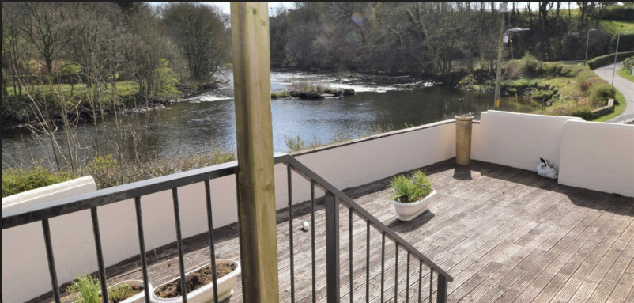We understand the property is entered in the Valuation Roll with a Rateable Value of £7,000. Further information is available from [www.scotland.gov.uk](http://www.scotland.gov.uk/)

The property is therefore eligible for 100% rates relief under the Small Business Bonus Scheme.

We understand the council tax band of the flat to be band B.

# ENERGY PERFORMANCE CERTIFICATE

# Energy Performance Rating - Band G (pub).

# TERMS

Offers in the region of £120,000 (ONE HUNDRED AND TWENTY THOUSAND POUNDS) for the heritable interest.

# SERVICES

The property benefits from mains,

Electricity, water, and drainage

.

**VAT**

VAT charged at the prevailing rate, only where applicable.

# LEGAL COSTS

Each party to bear their own legal costs.

# DATE OF ENTRY

# To be mutually agree

**VIEWING AND FURTHER INFORMATION**

Strictly by appointment through the sole letting agent Allied Surveyors Scotland plc.

Scott Morton / Allan McMillan | Tel. 01387 254 424

[Scott.morton@gmthomson.co.uk](mailto:Scott.morton@gmthomson.co.uk) / [Allan.mcmillan@gmthomson.co.uk](mailto:Allan.mcmillan@gmthomson.co.uk)

**Allied Surveyors Scotland plc** registered office address is Herbert House, 24 Herbert Street, Glasgow, G20 6NB. Registration No: SC180267 – Registered in Scotland. A list of Directors can be obtained at this address. Allied Surveyors Scotland plc for themselves and for their client whose agent they are give notice that: (1) These particulars are set out as a general outline only for the guidance of intended purchasers or tenants and do not constitute any part of an offer or contract. (2) All descriptions, dimensions, reference to condition and necessary permissions for use and occupation and other details are given without responsibility and any intending purchaser or tenant should not rely on them as statements or presentations of fact but must satisfy themselves by inspection or otherwise as to the correctness of each of them. (3) No person in the employment of Allied Surveyors Scotland plc has any authority to make or give representation or warranty whatever in relation to this property. (4) Unless otherwise stated all prices and rents are quoted exclusive of VAT. Prospective purchasers or lessees must satisfy themselves independently as to the incidence of VAT in respect of any transaction. (5) All plans based upon Ordnance Survey maps are reproduced with the sanction of the controller of H.M. Stationery. **Publication Date: December 2024**