

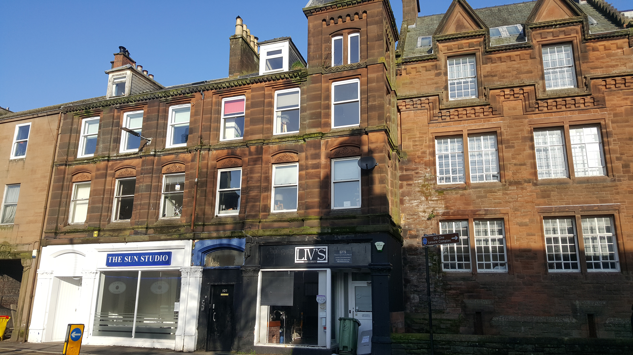

Tel.01387 254 424 @Allied_Scotland

www.alliedsurveyorsscotland.com

107 ENGLISH STRETT, DUMFRIES
TO LET (MAY SELL)
FLEXIBLE COMMERCIAL SPACE
CURRENTLY USED AS HAIRDRESSING SALON
CENTRAL LOCATION WITH STRONG PASSING FOOTFALL
FLEXIBLE ACCOMMODATION WITH POTENTIAL FOR WIDE RANGING USES
OFFERS FOR LET IN THE REGION OF £9,000 p.a. INVITED

LOCATION
The subject is situated in a central, location nearby the town centre of Dumfries, occupying a prominent corner position with strong passing footfall and vehicular traffic.

Neighbouring properties vary in terms of use, including shops, local Authority offices, a large leisure centre and hot food takeaways.

DESCRIPTION
The subject comprises a three story end terraced property providing modern commercial accommodation. The property is versatile with the accommodation lending itself easily to a variety of different uses including office accommodation, retail or a hairdressing/beauty salon .

Externally, there is a courtyard area to the rear.

ACCOMMODATION
The subject offers flexible modern accommodation over three floors including:

Ground Floor: Large main shop floor, separate studio/office, kitchenette area, WC

First Floor: Studio/office space, smaller office/dressing room with shower, toilets, store room

Second Floor: Studio/office space, kitchen/staff room.

FLOOR AREA
We calculate the net internal floor area of the subject to be circa 223m2 (2400 sq.ft.

Space | Area
Main floor/offices | 167m2 (1798 sq.ft.)
Other (Kitchens, stores, toilets etc) | 56m2  (603sq.ft.)

RATING ASSESSMENT & USE
The subject benefits from use Class 1A (Shops, financial, professional and other services).
We understand the property is entered in the Valuation Roll with a Rateable Value of £7,300
The property is therefore eligible for 100% rates relief under the Small Business Bonus Scheme.
Further information is available from www.scotland.gov.uk

ENERGY PERFORMANCE CERTIFICATE
Energy Performance Rating – C (43)

TERMS
Offers for let in the region of £9,000 (plus VAT) per annum are invited.
Offers for sale may be considered.

SERVICES
The property benefits from mains electricity, water and drainage. Heating is provided by a Gas fired combi boiler.
Lighting is generally modern LEDs and we also understand that ‘Ring’ doorbells are included to the front and rear.

VAT
VAT is charged on the rent.

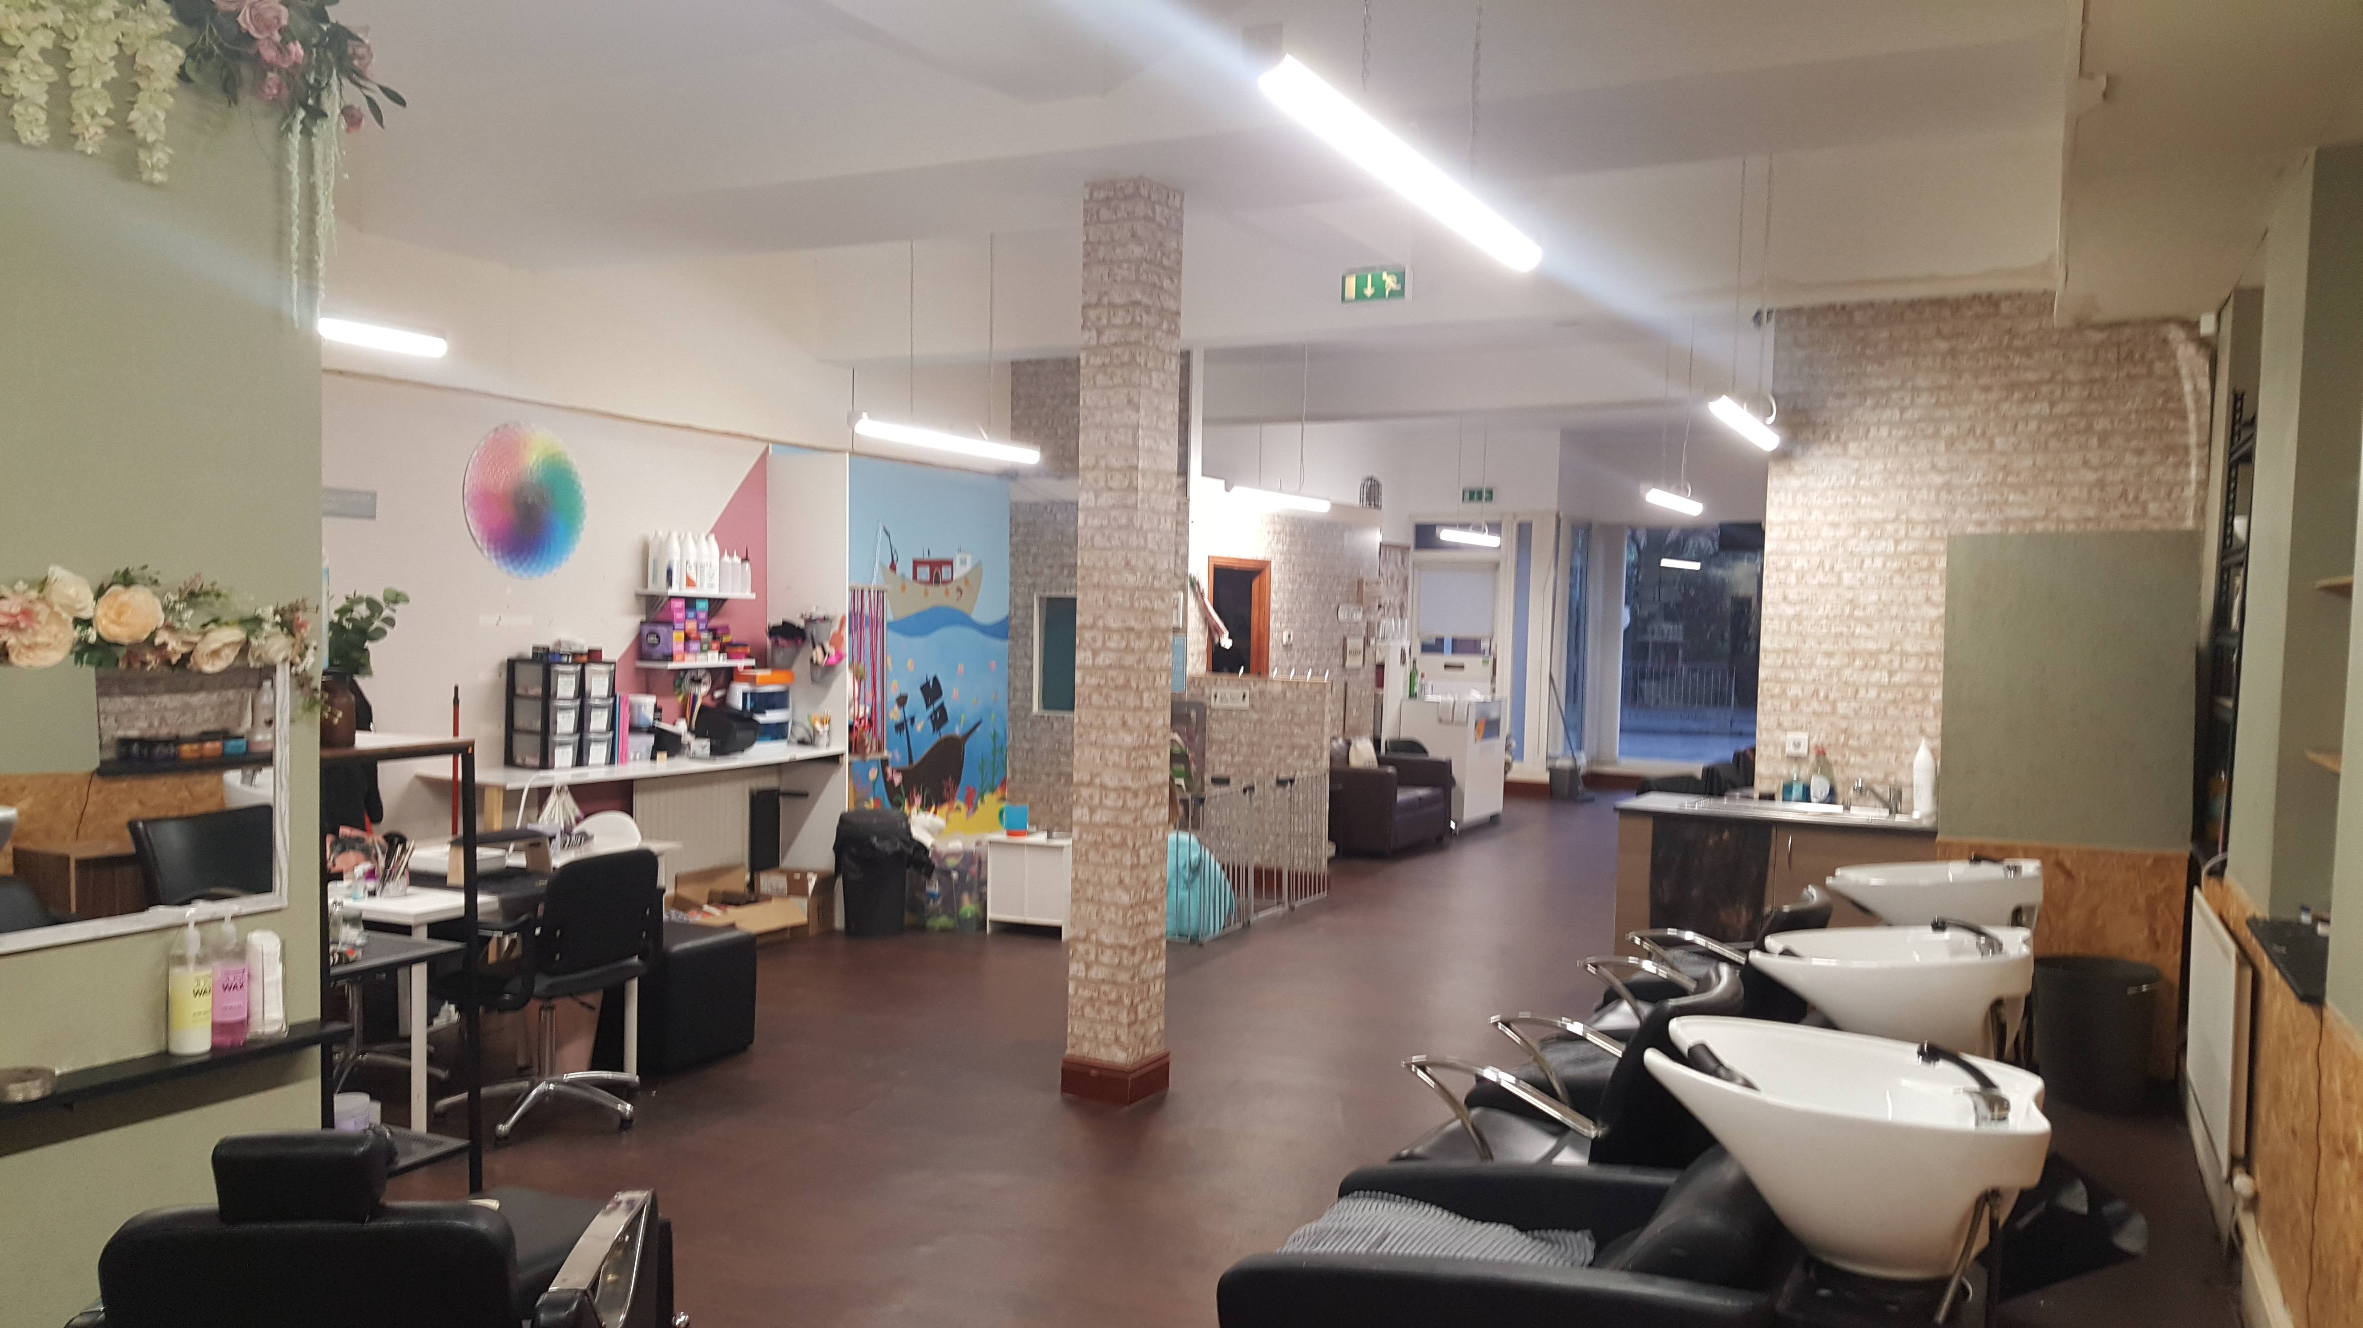
LEGAL COSTS
Each party to bear their own legal costs.

EQUIPMENT
Please note: Some of the existing equipment may be available for purchase via separate negotiation with the outgoing tenant.

DATE OF ENTRY
Entry available from 1st June 2025.
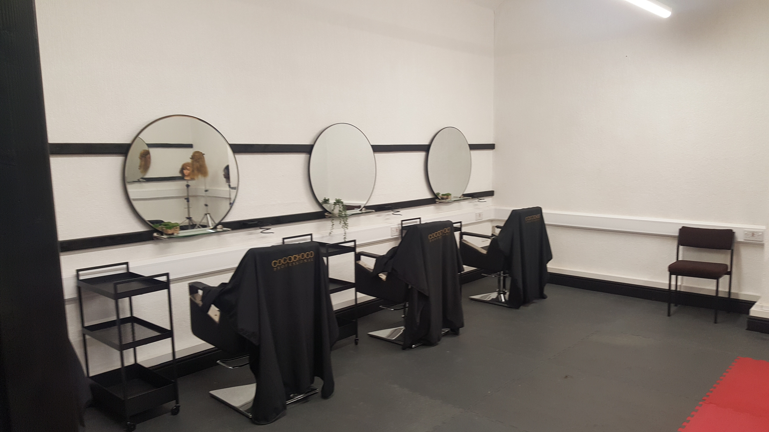
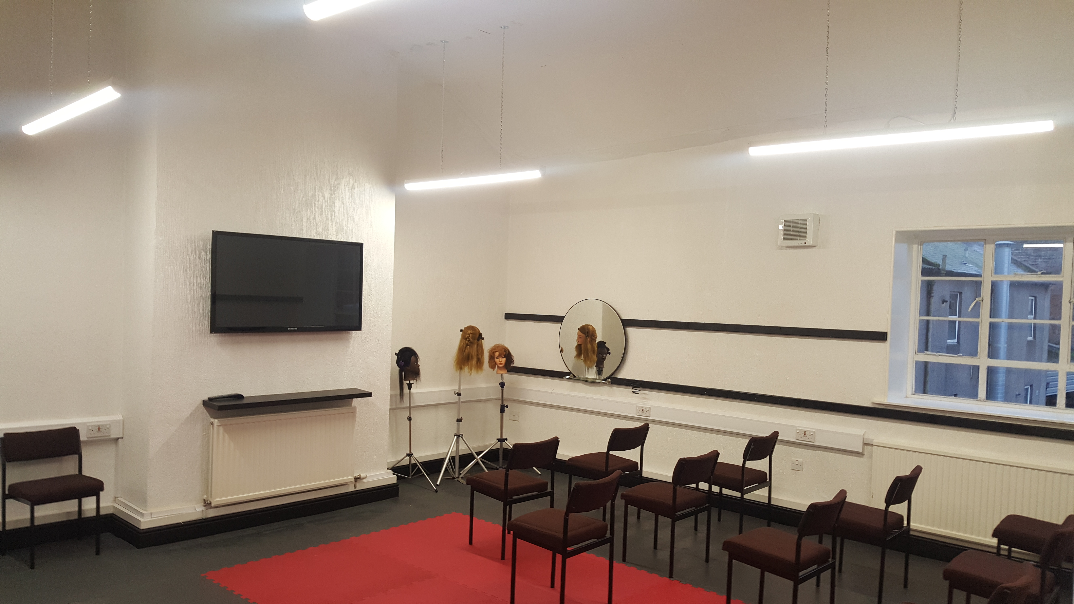

VIEWING AND FURTHER INFORMATION
By appointment only through the sole letting agent G M Thomson & Co.
Allan McMillan/Scott Morton| Tel. 01387 254 424
Allan.mcmillan@gmthomson.co.uk/scott.morton@gmthomson.co.uk

